Model Choices
Milestone 3: Modelling Strategy, Implementation, Tuning and Evaluation
BIN381 Group 5: Digital Access, Education and Employment in South Africa
Jandre Neethling · Henri Claassen · Declin Vorkel

1. Purpose and scope
This document records which models were considered for Milestone 3, why each one was chosen, how they were implemented and tuned in R, how they performed on the held-out test sets, and which model was selected in the end. Sections 2–9 cover Task 1 of the Milestone 3 brief (Modelling Strategy): restating the analytical question, identifying the modelling task, selecting candidate models, and explaining their assumptions, parameter choices and training procedure. Sections 10–18 cover the model tuning and the technical evaluation: household-grouped cross-validation, hyperparameter and threshold tuning, test-set performance, the checks of the education × internet interaction, the comparison matrix and the final model selection.
Sections 2–9 describe the models as they were first fitted: once, on the training data only, with documented starting parameters and without using the test sets. Tuning, evaluation and selection were then done in a separate notebook (sections 10–18), in a fixed order, so that every parameter, threshold and choice was made on the training data before the test sets were used, once, for the final comparison.
Final model choice: the survey-weighted logistic regression is selected for the employment question (test AUC 0.765, against 0.727 for a demographics-only baseline) and the survey-weighted linear regression for the income question. The random forests predict slightly better, but by too little to outweigh the regressions’ ability to test the education × internet interaction directly. Section 16 gives the full reasoning.
Contributions: Henri Claassen chose, implemented and fitted the candidate models (sections 2–9). Jandre Neethling did the tuning, technical evaluation, model comparison and final model selection (sections 10–18).
The code is in three Quarto notebooks and one shared R script in the project repository:
File | Contents
Scripts/3.1) Employment Model.qmd | Employment question (research areas B and C): three classification models
Scripts/3.2) Income Model.qmd | Income question (research area D): two regression models
Scripts/3.3) Model Evaluation.qmd | Tuning with household-grouped cross-validation, thresholds, baselines, test-set evaluation, interaction checks, comparison matrix and final model selection (sections 10–18)
R/model_preparation.R | Shared data preparation, predictor lists and model formulas, used by both notebooks and intended for the evaluation notebook and the Shiny app
Models/*.rds | The five models as first fitted with starting parameters (employment_logistic, employment_tree, employment_forest, income_linear, income_forest)
Models/*_tuned.rds, *_baseline.rds | The tuned decision tree and random forests, and the demographics-only baseline models
Models/employment_thresholds.csv | The tuned classification threshold of each employment model, needed by the Shiny app

2. Analytical question and modelling tasks
National Treasury has to decide how to divide limited funding between digital-access subsidies and education programmes. The key question from Milestone 1 is whether household internet access and education reinforce each other (complements) or can stand in for each other (substitutes) in the labour market. The Milestone 1 analytics goal was to model employment status from education level, digital access and the interaction between the two, controlling for demographic, geographic and household factors.
The Milestone 1 technical success criteria fix what the models must deliver:
- The education × connectivity interaction must be tested for statistical significance at α = 0.05.
- Its direction (reinforcing or substituting) must be reported as an odds ratio or equivalent effect size.
- The model must achieve acceptable discriminative performance on a held-out test set.
- The findings must be checked across at least two modelling approaches, such as logistic regression and a tree-based method.
This leads to two modelling tasks:
Question | Task | Outcome | Data
Is education associated with employment, and does internet access strengthen or replace that link? (areas B and C) | Binary classification | employed (Employed / Unemployed) | model_train.csv: labour force aged 15–64
Among employed people, is income related to education and internet access? (area D, exploratory) | Regression | log_salary (log of monthly salary) | income_train.csv: employed people who reported a salary of at least R100

Clustering was not chosen, because both questions have a known outcome. A supervised model is needed to estimate how the outcome relates to education and internet access. All results are associations, not causes, because the data are a single 2024 cross-section.

3. Data used for modelling
The models use the validated Milestone 2 training files. The Milestone 2 validation design is preserved: the train/test split was made by household (80% of households for training, set.seed(67)), so no household appears in both sets, and the test sets are left untouched for evaluation.
Both notebooks read their data through a shared function in R/model_preparation.R (prepare_employment_data() and prepare_income_data()). The same functions are used for the test sets and for new data in the Shiny app, so every file is prepared identically. The functions:
- read household_id as text (18-digit IDs would otherwise be rounded and households merged),
- apply fixed category levels and reference levels, written out in the script rather than taken from the data, so that training, test and new data always get identical factors,
- leave out rows with unknown education (matric_plus blank) and, for income, unknown household internet (any_home_internet blank), and
- keep only the design columns, the outcome and the chosen predictors.
None of these steps learn anything from the data, so they cannot leak information from the test set. Rows with unknown education are left out rather than imputed: they are a small share, education is the variable the question is about (so an imputed value would be a guess at the answer), and leaving them out means every model is fitted and later compared on exactly the same people.
Training file | Rows in file | Rows removed | Rows used | Households
model_train.csv | 23,041 | 370 (unknown education) | 22,671 | 13,298
income_train.csv | 14,371 | 316 (unknown education or internet) | 14,055 | 10,272
Table 1: Rows used to fit the models
The employment target is mildly imbalanced (about 65% employed, 35% unemployed, a ratio of roughly 2:1). This is not severe enough to need resampling such as SMOTE or down-sampling, so all models are fitted to the data as they are. How the smaller Unemployed class is handled at prediction time (the classification threshold) is left to tuning.

4. Predictor selection
model_data.csv has 21 candidate predictors, several of which measure the same thing in different ways. Putting overlapping columns in one model splits a single effect across several coefficients, makes the interaction hard to read and can make the estimates unstable. One version of each idea was therefore kept:
Kept | Left out | Reason
matric_plus (0/1) | education_band | The policy question is framed as with or without matric. A 0/1 variable gives the interaction one odds ratio instead of six (one per education band), which answers the question directly.
any_home_internet (0/1) | has_fixed_internet, has_mobile_internet, digital_access_score | Internet access is the policy lever (connectivity subsidies). The other columns are its parts, or a score that includes it, so using them together would count the same access twice.
has_computer, smartphone_access |  | Separate controls for other kinds of digital access, so the internet effect is not simply device ownership, which also reflects household wealth.
matric_plus × any_home_internet (in the regression formula) | edu_digital_group | edu_digital_group is the same combination stored as one categorical column; using both would duplicate the interaction.
household_size, n_children_under15, elderly_in_household, female_x_children, other_member_matric | dependency_ratio | dependency_ratio is calculated from the counts of children, elderly and working-age members that the other household columns already describe.
age_centred, age_centred_squared, female, population_group, province, settlement_type |  | Standard labour-market controls. Without them the internet effect would partly be an age, gender, location or population-group effect.
Table 2: Predictors kept and left out (employment model)
This gives 15 predictors for the employment models. The income file was built with fewer columns in Milestone 2, so the income models use the 8 that apply: matric_plus, any_home_internet, the two age terms, female, population_group, province and settlement_type. The same choices were made in both, so the two sets of models can be compared.
population_group is a sensitive attribute. It is included as a control, so that the education and internet effects are estimated within population groups rather than being confounded with South Africa's historical inequality. It is also needed for fairness checks during evaluation. It is not meant for predicting outcomes for individual people.
household_id and person_weight are never predictors. household_id defines the clusters in the survey design and person_weight is the Stats SA survey weight.
Two checks were run before fitting. The correlation between the numeric household predictors is at most about 0.8 (household_size and n_children_under15): high, but not so high that the coefficients become unstable, and both are controls rather than the effects of interest. Each of the four matric × internet groups also has enough people to estimate the interaction: the smallest, people with matric but no home internet, has 1,016 people in the employment training data and 555 in the income training data.

5. Employment models
Three models were chosen. They answer the question in different ways and are not only competing on accuracy, in line with the brief's principle that the highest-scoring model is not automatically the best one:
Model | Role | Main reason for choosing it
1. Survey-weighted logistic regression (survey::svyglm) | Main explanatory model | The only candidate that estimates the education × internet interaction directly as an odds ratio with a significance test, which success criteria 1 and 2 require.
2. Decision tree (rpart) | Interpretable tree-based check | Finds interactions without being told about them, and produces rules that non-technical stakeholders can follow. Covers success criterion 4.
3. Random forest (ranger) | Predictive benchmark | Captures non-linear effects and interactions the regression cannot. Shows how much predictive power the simpler models give up.
Table 3: Candidate employment models

5.1 Survey-weighted logistic regression

Why it was chosen
Logistic regression is the standard model for a binary outcome, and it is the only candidate whose output directly answers Treasury's question. With the interaction matric_plus × any_home_internet in the model, the exponentiated interaction coefficient is an odds ratio: above 1 means internet access goes with a larger employment advantage for people with matric (complements), and below 1 means a smaller one (substitutes). It comes with a confidence interval and p-value, so it can be tested at α = 0.05 as Milestone 1 requires. Every other coefficient is also an interpretable odds ratio, which suits a policy stakeholder who needs to explain the result.
The survey-weighted version (svyglm from the survey package) was chosen over an ordinary glm() for two reasons. First, Stats SA sampled some groups more heavily than others, and the person weights correct for this, so the odds ratios describe the South African labour force rather than the sample. Second, people in the same household are not independent, because they share every household-level predictor. Treating households as clusters gives standard errors, and so a significance test for the interaction, that allow for this. An ordinary glm() would treat all 22,671 people as independent and understate the uncertainty.

Assumptions
Assumption | How it is handled
Binary outcome | employed has two levels, with Unemployed as the reference, so the model predicts the probability of being Employed.
Independent observations | Households are the clusters in the survey design. The Stats SA primary sampling unit is not in model_data.csv, so the household is the finest cluster available.
Log-odds linear in the numeric predictors | Age has a curved relationship with employment, so age_centred_squared is included next to age_centred (Milestone 2, section 10.4).
No strong multicollinearity | Overlapping predictors were removed (section 4); the remaining correlations are acceptable.
Enough cases per parameter | About 8,000 unemployed people for 30 coefficients, far above the usual minimum of 10–20 events per coefficient.

Parameters
- family = quasibinomial(): the logistic link. svyglm uses the quasi-binomial family with survey weights because weighted counts are not whole numbers; the coefficients are identical to binomial().
- Survey design: ids = ~household_id, weights = ~person_weight.
- Formula: employed ~ matric_plus * any_home_internet + the 13 control predictors.
- No hyperparameters to tune. Only the classification threshold is left for evaluation.

5.2 Decision tree

Why it was chosen
Milestone 1 committed to checking the findings with a tree-based method. A decision tree is the most interpretable tree-based model: it splits the data into groups using simple if-then rules. It makes no assumptions about linearity, handles categorical predictors directly and finds interactions on its own. If it splits on internet access differently for people with and without matric, that is independent support for the regression's interaction. If it does not, that is also informative for evaluation. Its rules can also be shown to non-technical stakeholders as a diagram.

Starting parameters
Parameter | Value | Reason
method | "class" | Classification tree for the two-level target.
maxdepth | 5 | At most five questions from the top of the tree to a prediction; a deeper tree is no longer readable, and readability is why a tree was chosen.
minbucket | 100 | Every final group contains at least 100 people (about 0.4% of the training data). This keeps the groups stable and avoids rules that describe very small, possibly identifiable groups.
cp | 0.001 | A split is kept if it improves the fit by at least 0.1%. Low on purpose: maxdepth and minbucket limit the size, and pruning is left to tuning.
xval | 0 | rpart's built-in cross-validation is switched off because it splits by person, which would put members of one household on both sides and overstate performance.

The tree uses the same 15 predictors as the regression, but without an explicit interaction term, because a tree forms interactions itself by splitting on one variable inside a split on another.

5.3 Random forest

Why it was chosen
A random forest grows many decision trees on bootstrap samples of the data, with each split considering only a random subset of the predictors, and averages their predictions. This gives more accurate and more stable predictions than a single tree, and it captures non-linear effects and complex interactions that the logistic regression's form rules out. Its role is a benchmark: if it predicts only slightly better than the logistic regression, the interpretable model loses little by being simple, which supports choosing it. It also provides a second check: if education and internet access remain important predictors in the forest, the finding does not depend on the regression's assumptions.
The ranger package was used instead of randomForest because it implements the same algorithm much faster and handles categorical predictors better.

Starting parameters
Parameter | Value | Reason
num.trees | 500 | Enough trees for predictions and importance scores to stabilise; more only cost time.
mtry | 3 | Predictors considered at each split: the standard √15 ≈ 3 for classification. The main tuning parameter.
min.node.size | 10 | The standard minimum leaf size for probability forests.
probability | TRUE | Predicts the probability of being employed rather than a class, so the threshold can be chosen and ROC-AUC calculated during evaluation.
respect.unordered.factors | "order" | Orders the levels of each categorical predictor (for example the nine provinces) by their share of employed people before splitting, instead of treating an arbitrary level order as meaningful.
importance | "permutation" | Measures how much predictions worsen when a predictor is shuffled. More reliable than impurity importance, which favours predictors with many levels.
seed | 67 | Makes the forest reproducible (the same seed as the Milestone 2 split).

5.4 Models considered but not used
- Penalised logistic regression (lasso/ridge): useful with many predictors. With 15 chosen predictors and over 20,000 rows a standard logistic regression is stable, and penalisation would shrink the interaction coefficient the question is about.
- k-nearest neighbours and support vector machines: give no interpretable effect sizes, and need scaled numeric inputs that do not suit mainly categorical predictors.
- Neural networks: a black box with no clear advantage on 15 tabular predictors, and hard to justify to a policy stakeholder.
- Gradient boosting (e.g. XGBoost): could be slightly more accurate than a random forest, but it needs much more tuning, and the forest already fills the benchmark role.
- Clustering: the question has a known outcome, so a supervised model is appropriate.

6. Income models
The income question is exploratory. Salaries are missing for a large share of employed people (Milestone 1 data-quality assessment), so the results describe people who reported a salary, not all employed people. Two models were chosen, meeting the requirement of at least two candidates and pairing a linear model with a tree-based model as for employment.

6.1 Survey-weighted linear regression
Why it was chosen: the outcome log_salary is continuous, so linear regression is the natural interpretable model. Using the log of salary (created in Milestone 2) reduces the strong right skew of salaries and means each coefficient can be read as a percentage difference in salary. With the same matric_plus × any_home_internet interaction as the employment model, it shows whether the salary premium for matric is larger (complements) or smaller (substitutes) in connected households, with a confidence interval and significance test. As for employment, the survey-weighted version with households as clusters gives population-representative estimates and correct standard errors.
Assumptions: a linear relationship with the numeric predictors (age enters as a linear and a squared term, since salaries rise with experience and then level off); roughly normal errors with constant variance (the log transformation makes salaries roughly symmetric, and residuals are checked during evaluation); and independent observations (handled by household clustering).
Parameters: family = gaussian(); design ids = ~household_id, weights = ~person_weight; no hyperparameters to tune.

6.2 Random forest (regression)
Why it was chosen: the forest predicts log_salary without assuming a linear shape and finds interactions itself. It is the benchmark for the linear model: it shows whether the linear model misses important structure, and whether education and internet access remain important predictors of income without the linear model's assumptions.
Starting parameters: num.trees = 500; mtry = 2 (the standard one third of 8 predictors for regression); min.node.size = 5 (the standard for regression forests); respect.unordered.factors = "order" (orders categories by average salary); importance = "permutation"; seed = 67.

6.3 Models considered but not used
- A single regression tree: the readable-tree role is already covered by the employment model, and the income question is exploratory.
- Gamma or log-normal GLM on raw salary: gives much the same answer as a linear model of log_salary but is harder to explain.
- Quantile regression: would show effects at low and high salaries separately; a possible extension, but beyond what the business question asks.

7. Use of survey weights
The regression models are survey-weighted and the tree-based models are not. This was a deliberate choice:
- The regression models are used to estimate effects for the population (the odds ratios and percentage differences Treasury will act on), so they must be representative. Survey weighting and household clustering are what make those estimates and their significance tests valid.
- The tree-based models are used to check the pattern and benchmark predictive performance, not to produce population estimates. The weights range from 50 to 5,531. In rpart a weighted tree would let a small number of heavily weighted people decide the splits, and in ranger weights become bootstrap sampling probabilities, so the most heavily weighted people would appear in almost every tree. Both would reduce the effective amount of data.
Weights are not lost for these models: the evaluation can still pass person_weight to the performance metrics to report population-weighted results next to the unweighted ones.

8. Implementation and reproducibility
- All models are built in R (4.6.1) with survey, rpart, rpart.plot and ranger, on the Milestone 2 training files only.
- Data preparation, predictor lists and formulas are defined once, in R/model_preparation.R, and shared by every notebook, so no model can be trained on data prepared differently.
- Every random step uses seed = 67, the same seed as the Milestone 2 split, so rerunning the notebooks gives identical models.
- No preprocessing step learns from the data (no imputation, scaling or target encoding), so there is no preprocessing leakage from the test set. The only learned parameters are the models' own, fitted on training data.
- Each notebook includes verification checks: row counts before and after preparation, no remaining missing values, no unexpected category values, and that every training row was used in the fit.
- The fitted models are saved to Models/ (employment_logistic.rds, employment_tree.rds, employment_forest.rds, income_linear.rds, income_forest.rds). Each notebook reloads them and confirms that they give identical predictions to the models in memory.
- All three notebooks render without errors, and the rendered output is in Rendered Documentation/Milestone 3/.

9. Handover to tuning and evaluation
The parameters above are starting values, not tuned values. The following is left for the tuning and evaluation stage:
Model | To tune
Logistic regression | Classification threshold only (with 65% employed, a 0.5 cut-off will rarely predict Unemployed)
Decision tree | cp (pruning), maxdepth, minbucket, and the threshold
Random forest (employment) | mtry, min.node.size, and the threshold
Linear regression (income) | Nothing
Random forest (income) | mtry (1–8), min.node.size

To keep tuning free of leakage, cross-validation should be grouped by household (for example caret::groupKFold(model_train$household_id, k = 5)), for the same reason the train/test split was. Parameters and thresholds should be chosen on the training folds only, and each test set used once, for the final comparison. The test sets must be prepared with the same functions (prepare_employment_data() and prepare_income_data()), and the notebooks show the code for loading each saved model and producing predictions.
This handover was carried out as planned. Sections 10–18 describe how.

10. Tuning and evaluation design
Tuning and evaluation are done in Scripts/3.3) Model Evaluation.qmd. It continues from the two modelling notebooks: it reads the training files through the same preparation functions, loads the saved models and tunes the models that have hyperparameters. The notebook works in a fixed order, so that the test sets cannot influence any choice:
Step | Data used | What happens
1. Folds | Training files only | Household-grouped cross-validation folds are built and checked (section 10.1).
2. Tuning | Training files only | The tree and forest parameters are tuned, the baselines are cross-validated and each employment model’s classification threshold is chosen, all from out-of-fold predictions (sections 11–12).
3. Refit | Training files only | The tuned models are refitted on the full training files and saved.
4. Test | Test files, used once | Every model is scored on the test sets with the parameters and thresholds fixed in steps 2–3 (section 13).
5. Interaction | Training files and fitted models | The education × internet interaction is tested and checked across the models (section 14).
6. Selection | Results of steps 2–5 | Comparison matrix and final model selection (sections 15–16).
Table 4: Order of the tuning and evaluation notebook

10.1 Household-grouped cross-validation
Tuning needs data the model was not fitted on, but the test set must stay untouched until the end. Five-fold cross-validation solves this with the training data alone: the training rows are divided into five folds, each model is fitted five times on four folds and scored on the fifth, and the five results are averaged. Every training row therefore gets one “out-of-fold” prediction from a model that never saw it.
The folds are grouped by household with caret::groupKFold(household_id, k = 5), for the same reason the Milestone 2 train/test split was: members of one household share every household-level predictor (internet access, computer, smartphones, household size), so splitting a household across folds would score the model on near-copies of people it was trained on and overstate its performance. set.seed(67) is set first, the same seed as the Milestone 2 split. In each fold the survey design of the regressions is rebuilt from that fold’s training rows only.
The folds were checked before use: every row is in exactly one fold, no household is split across folds (for both the employment and the income data), and the share of employed people is similar in every fold (0.635 to 0.658), so each fold is a fair small-scale copy of the training data.

10.2 Baseline models
The Milestone 2 success criteria require the models to be compared with a demographics-only baseline: a model that knows a person’s age (age_centred, age_centred_squared), sex, population group, province and settlement type, but nothing about their education, digital access or household. If the full models do not predict clearly better than the baseline, education and digital access add little predictive information beyond who and where a person is. Each baseline is a survey-weighted regression with the same design as the main regression, so the only difference between the two is the predictors. For income, the simplest possible baseline (predicting everyone’s salary as the weighted training average) is also included.

10.3 Evaluation metrics
No single metric is enough, so each task gets several that measure different things. About 35% of the labour force is unemployed, so a model that always predicts Employed would already be 65% accurate: accuracy on its own is misleading and is not used to choose anything.
Metric | What it measures | Why it is used
ROC-AUC | How well the predicted probabilities rank employed people above unemployed people, over every threshold | Main tuning and comparison metric; independent of the threshold and class balance. Milestone 2 set AUC ≥ 0.70 as the minimum.
Balanced accuracy | Average of sensitivity and specificity | Treats both classes as equally important.
Sensitivity / specificity | Share of employed / unemployed people classified correctly | Specificity covers the smaller class, the one policy is most concerned with.
Precision, F1 | Share of Employed predictions that are correct; balance of precision and sensitivity | Required by the brief’s list of classification metrics.
Brier score | Mean squared difference between predicted probability and outcome (0 = perfect) | The Shiny app shows probabilities, so they must be accurate, not only well ranked.
RMSE, MAE, R² (income) | Size of the errors on the log-salary scale, and the share of variation explained | Standard regression metrics, on the scale the models were fitted on.
Table 5: Evaluation metrics
Every test-set metric is reported unweighted (how well the model predicts for the people in the sample) and weighted by person_weight (how well it would predict for the South African population the sample represents).

11. Tuning the employment models

11.1 Logistic regression and baseline
The logistic regression has no hyperparameters, but it is still cross-validated: its out-of-fold predictions give a cross-validated AUC to compare with the other models and are used to choose its threshold (section 11.4). Its mean cross-validated AUC is 0.764 (standard deviation 0.009 across folds), against 0.723 (0.010) for the demographics-only baseline.

11.2 Decision tree
Three parameters control the tree’s size and were tuned together over a grid of 36 combinations, each fitted once per fold. rpart’s own cross-validation stays switched off (xval = 0), because it splits by person.
Parameter | Values tried | Reason for the range
maxdepth | 3, 4, 5 | Not above 5, because the tree was chosen for readability (section 5.2).
minbucket | 50, 100, 200 | Not below 50, so no rule describes a very small, possibly identifiable group.
cp | 0.0005, 0.001, 0.002, 0.005 | Minimum improvement a split must give to be kept (pruning).
Table 6: Decision tree tuning grid
Many settings gave almost the same AUC, with differences smaller than the variation between folds. The tree was therefore chosen with the one-standard-error rule (Breiman et al., 1984): among all settings whose mean AUC is within one standard error of the best, the tree with the fewest leaves is chosen. This picks the simplest tree that performs as well as the best one within the precision the cross-validation can measure, which suits a model chosen for being readable.
The best setting (maxdepth 5, minbucket 100, cp 0.0005, 12 leaves) had a cross-validated AUC of 0.7131, giving a limit of 0.7079. The selected tree has maxdepth = 5, minbucket = 200 and cp = 0.001, with 9 leaves and a cross-validated AUC of 0.7106. The best trees all use the maximum depth, so the depth limit set for readability costs some accuracy: even the best tree is below the demographics-only baseline (0.723).
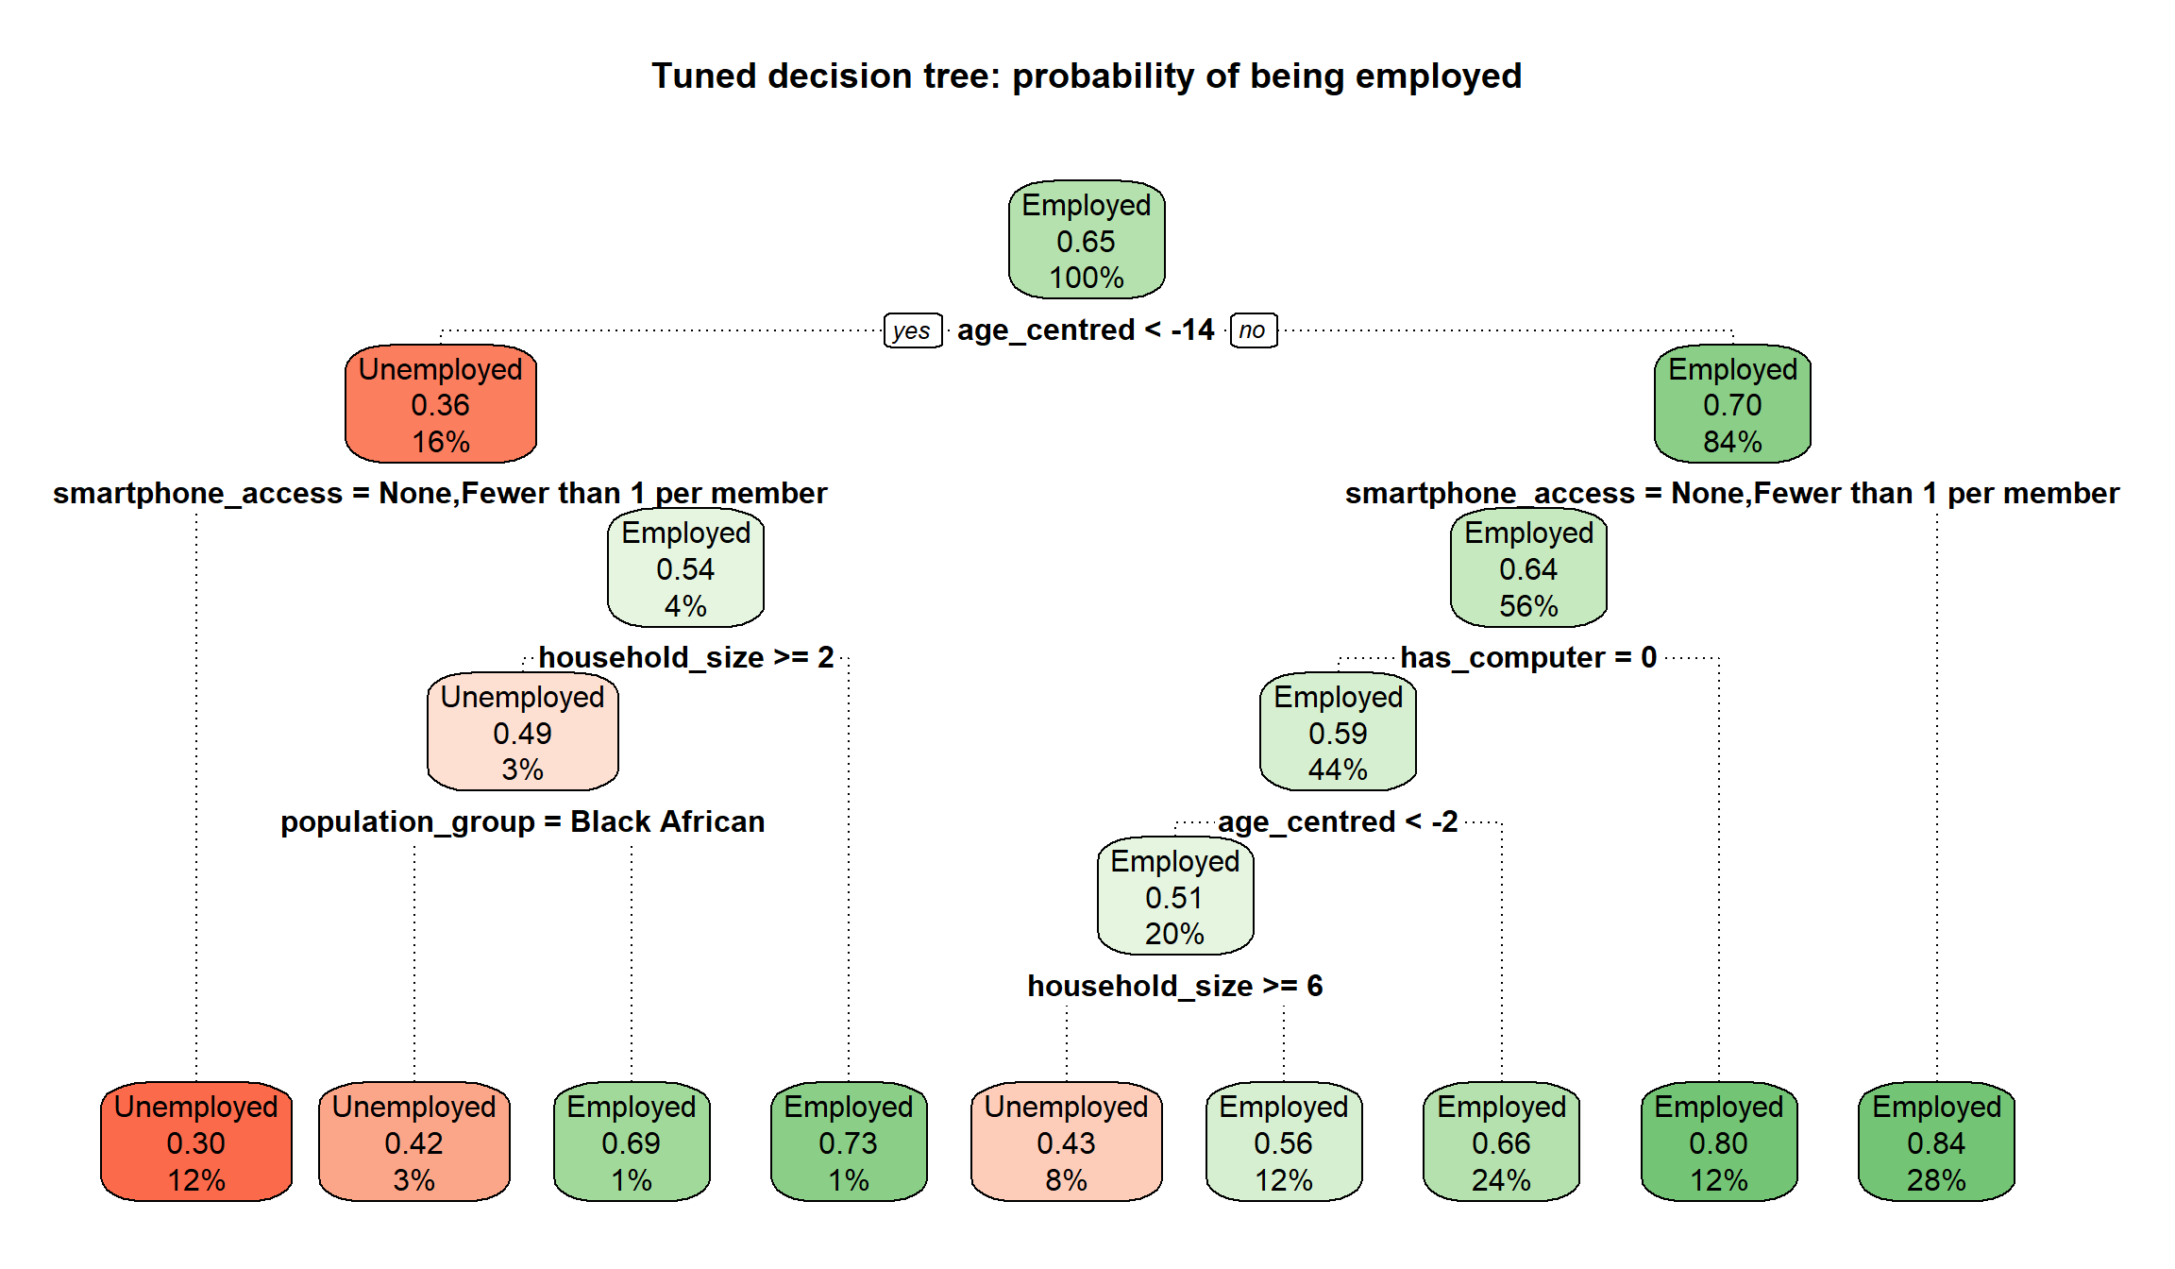
Figure 1: The tuned decision tree (probability of being employed in each leaf)
The tuned tree splits only on age, smartphone access, computer ownership, household size and population group. It never splits on matric_plus or any_home_internet, so it cannot show an education × internet interaction (section 14.3).

11.3 Random forest
The forest’s main parameters are mtry (how many predictors each split may choose from) and min.node.size (the smallest leaf in each tree). num.trees is not tuned, because more trees only make the predictions more stable: 300 trees were grown during tuning to save time and the final forest has 500. The forest is chosen by the highest mean cross-validated AUC; the one-standard-error rule is not used, because the forest is not meant to be readable.
Parameter | Values tried | Reason for the range
mtry | 2, 3, 4, 6 | Small values make the trees more different from each other; large values let each split use the strongest predictors. 3 (√15) was the starting value.
min.node.size | 10, 30, 100, 200, 400 | 10 was the starting value. A first run that stopped at 100 chose 100, the edge of the grid, so larger values were added.
Table 7: Employment random forest tuning grid
The selected forest uses mtry = 3 and min.node.size = 100, with a cross-validated AUC of 0.771, against 0.763 for the starting values (mtry = 3, min.node.size = 10). Small leaves let each tree fit individual people too closely; larger leaves give smoother probabilities that rank people better.

11.4 Classification thresholds
A model’s probabilities become Employed/Unemployed predictions through a threshold. The default of 0.5 is only right when both kinds of error are equally costly and the classes are balanced. With 65% employed, a 0.5 threshold labels most people Employed and misses many of the unemployed. Each model’s threshold was chosen from its out-of-fold predictions (never the test set) as the threshold that maximises balanced accuracy (Youden’s J = sensitivity + specificity − 1), which gives both classes equal importance.
Model | Tuned threshold | Balanced accuracy at 0.5 | Balanced accuracy tuned | Specificity at 0.5 | Specificity tuned
Baseline | 0.674 | 0.634 | 0.659 | 0.393 | 0.683
Logistic regression | 0.639 | 0.660 | 0.695 | 0.456 | 0.678
Decision tree | 0.616 | 0.629 | 0.656 | 0.378 | 0.536
Random forest | 0.654 | 0.659 | 0.701 | 0.440 | 0.726
Table 8: Tuned thresholds and their effect on the out-of-fold predictions
At 0.5 every model identifies fewer than half of the unemployed. The tuned thresholds, all between 0.6 and 0.7, trade some sensitivity for much higher specificity and raise balanced accuracy for every model. Accuracy falls slightly, as expected, because the larger class is now predicted less often. The thresholds are saved in Models/employment_thresholds.csv, because they are part of each classification model and the Shiny app needs them.

12. Tuning the income models

12.1 Linear regression and baselines
The linear regression has no hyperparameters. Its cross-validated performance, with the two baselines:
Model | CV RMSE | CV MAE | CV R²
Training average | 1.149 | 0.903 | −0.012
Baseline (demographics only) | 1.037 | 0.794 | 0.176
Linear regression | 0.948 | 0.727 | 0.311
Table 9: Cross-validated performance of the income regressions (log-salary scale)

12.2 Random forest
mtry was tried over its full range for 8 predictors (1, 2, 3, 4, 6, 8; 8 is bagging) and min.node.size over 5, 20, 50, 100 and 200 (a first run that stopped at 50 chose 50, so larger values were added). The setting with the lowest mean cross-validated RMSE was chosen: mtry = 3 and min.node.size = 200 (CV RMSE 0.943). This is again at the edge of the grid, but the grid was not extended: the ten best settings differ in mean RMSE by only 0.0028, well below the fold-to-fold standard deviation of about 0.004, so larger leaves could not give a meaningful improvement.

12.3 Tuned settings
The chosen settings were used to refit each tuned model on the full training file (500 trees for the forests). The regressions have nothing to tune, so the models saved by the modelling notebooks are used unchanged. The untuned models stay in Models/ as the documented starting point, and the tuned models are saved next to them with _tuned in the name.
Setting | Starting value | Tuned value
Tree maxdepth | 5 | 5
Tree minbucket | 100 | 200
Tree cp | 0.001 | 0.001
Employment forest mtry | 3 | 3
Employment forest min.node.size | 10 | 100
Income forest mtry | 2 | 3
Income forest min.node.size | 5 | 200
Table 10: Starting and tuned hyperparameters

13. Test-set evaluation
From this point nothing is tuned or chosen. The test sets are read with the same preparation functions and checked: the employment test set has 5,574 people in 3,317 households (35.5% unemployed), the income test set 3,560 people in 2,569 households, and neither shares a single household with its training set.

13.1 Employment results
Metric | Baseline | Logistic regression | Decision tree | Random forest
AUC | 0.727 | 0.765 | 0.710 | 0.774
AUC 95% CI (DeLong) | 0.713–0.741 | 0.752–0.778 | 0.696–0.724 | 0.761–0.786
Balanced accuracy | 0.664 | 0.693 | 0.656 | 0.699
Sensitivity | 0.641 | 0.707 | 0.764 | 0.671
Specificity | 0.687 | 0.679 | 0.549 | 0.728
Precision | 0.788 | 0.801 | 0.755 | 0.817
F1 | 0.707 | 0.751 | 0.760 | 0.737
Accuracy | 0.658 | 0.698 | 0.688 | 0.691
Brier score | 0.194 | 0.183 | 0.198 | 0.180
AUC, population-weighted | 0.732 | 0.770 | 0.711 | 0.779
Table 11: Employment models on the test set (each at its tuned threshold)
The test results are close to the cross-validated results, so the cross-validation gave a realistic estimate and the models are not overfitted. Every model clears the AUC ≥ 0.70 threshold set in Milestone 2, including the demographics-only baseline, so that threshold on its own does not separate the models; the comparison with the baseline is what shows whether education, digital access and the household predictors add anything. The population-weighted metrics are very similar to the unweighted ones.
Model | Employed correctly identified | Employed predicted Unemployed | Unemployed correctly identified | Unemployed predicted Employed
Baseline | 2,306 | 1,290 | 1,359 | 619
Logistic regression | 2,544 | 1,052 | 1,344 | 634
Decision tree | 2,749 | 847 | 1,085 | 893
Random forest | 2,412 | 1,184 | 1,439 | 539
Table 12: Confusion matrices on the test set (3,596 employed and 1,978 unemployed people)
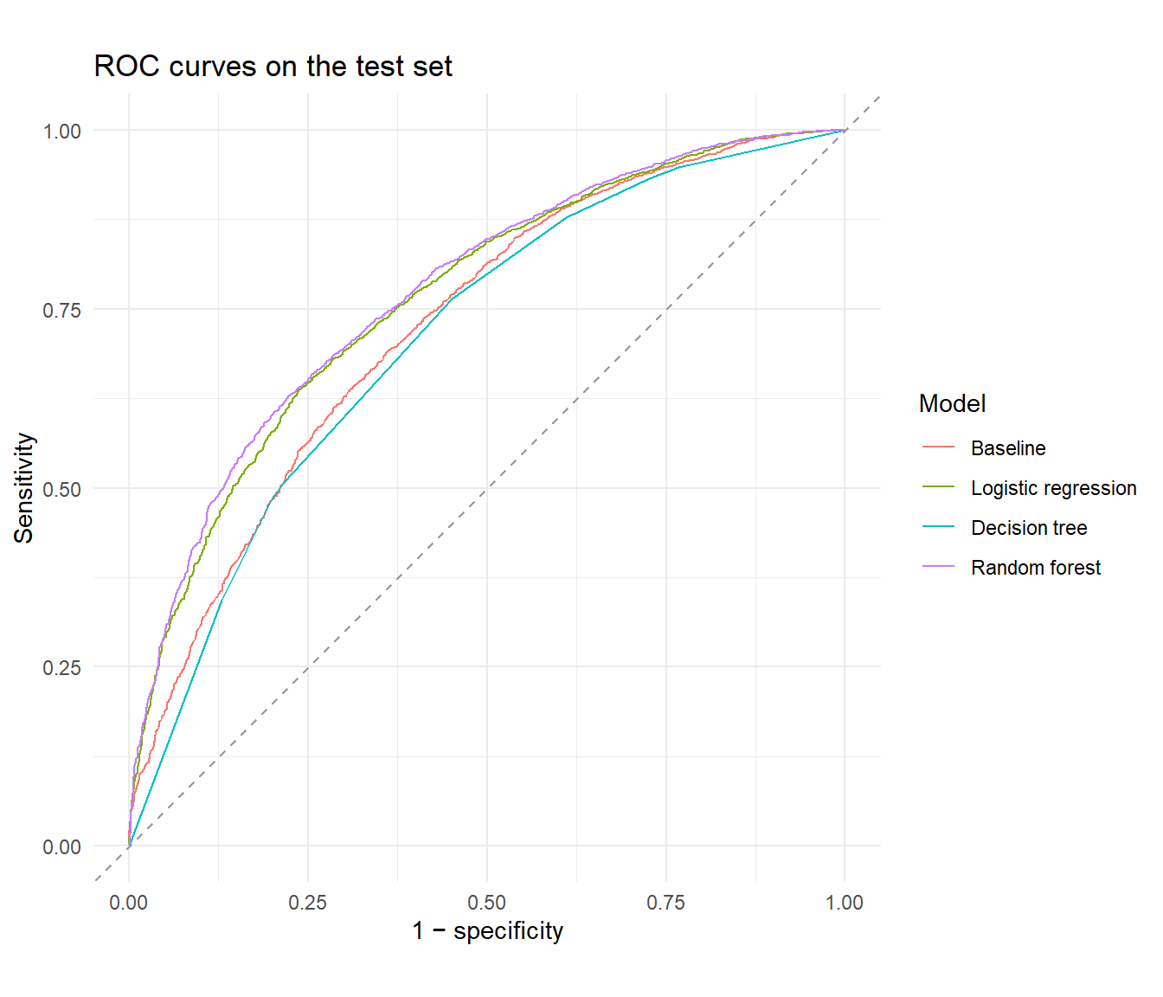
Figure 2: ROC curves of the employment models on the test set
The DeLong test checks whether the difference in AUC between two models on the same test people is larger than chance. Each model was compared with the logistic regression:
Comparison | AUC difference | DeLong p-value
Logistic regression vs baseline | +0.038 | < 0.0001
Logistic regression vs decision tree | +0.055 | < 0.0001
Logistic regression vs random forest | −0.009 | 0.0019
Table 13: DeLong tests of the AUC differences
The DeLong test treats people as independent. Household members are not fully independent, so these p-values are somewhat too small, and a difference that is only just significant should be read with caution.

13.2 Calibration
The Shiny app will show predicted probabilities, so they should match reality: of the people given a 70% probability, about 70% should be employed. The test people were grouped into ten equal-sized bins by predicted probability, and each bin’s average prediction was compared with its actual share employed. All four models lie close to the diagonal across the whole range, so none is systematically too confident or too cautious.
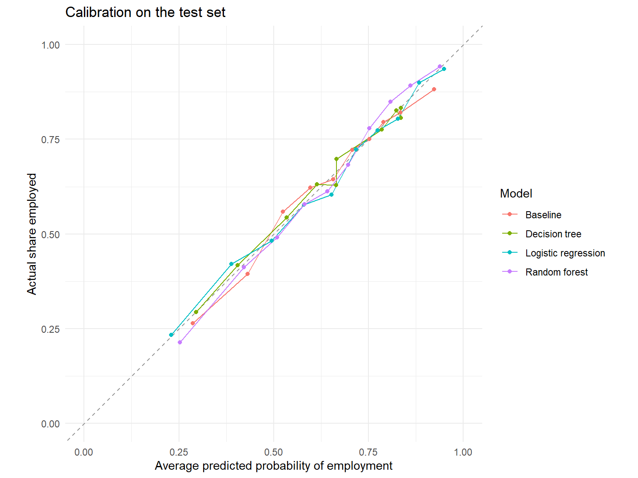
Figure 3: Calibration of the employment models on the test set

13.3 Income results
Model | RMSE | MAE | R² | R², population-weighted
Training average | 1.145 | 0.900 | −0.021 | −0.001
Baseline (demographics only) | 1.038 | 0.795 | 0.161 | 0.187
Linear regression | 0.949 | 0.729 | 0.298 | 0.315
Random forest | 0.937 | 0.716 | 0.316 | 0.329
Table 14: Income models on the test set (log-salary scale)
Both models clearly beat the two baselines, and the test results match the cross-validated ones. Even so, both explain only about 30% of the variation in log salary: education, internet access, age, sex, population group and location leave most salary differences unexplained (occupation, industry and hours worked are not in the data). An RMSE of about 0.95 on the log scale means an individual prediction is typically off by a factor of about 2.6 in rand terms, so the income models are useful for average differences between groups, not for predicting an individual’s salary.
The residuals of the linear regression are centred on zero across the whole range of fitted values with roughly constant spread, so the linear form and the constant-variance assumption hold reasonably well. The Q-Q plot shows heavier tails than a normal distribution (a few people earn far more or less than predicted); with over 14,000 people this does not affect the coefficients or their confidence intervals much.

13.4 How closely the models agree
The metrics show how well each model predicts, but not whether the models make the same predictions. The test-set predictions of each pair of models were therefore correlated, and the agreement of their final classifications was measured with Cohen’s kappa.
- The logistic regression and the random forest correlate at 0.93 and give the same class to 89% of test people (kappa 0.78, substantial agreement). The forest’s extra flexibility finds very little the regression misses.
- For income, the linear regression and the forest correlate at 0.96. Both correlate with the actual log salary at only about 0.55: they capture the same group differences and miss the same individual variation.
- The decision tree agrees least with the other models (0.66 with the baseline), because it sorts everyone into only 9 groups.
- The baseline correlates at 0.86 with the logistic regression and 0.81 with the forest. That difference is the information that education, digital access and the household predictors add.

14. The education × internet interaction
The Milestone 1 and 2 success criteria require the interaction to be tested with a likelihood-ratio test at α = 0.05, reported as an odds ratio and as predicted probabilities for each education × internet group, and checked with at least two modelling approaches.

14.1 Likelihood-ratio tests
regTermTest(..., method = "LRT") compares each regression with and without the interaction term using the Rao-Scott likelihood-ratio test, which adjusts the ordinary test for the survey weights and household clustering.
Model | Interaction effect | 95% CI | LRT p-value | Significant at 0.05
Employment (logistic regression) | Odds ratio 1.292 | 1.057–1.580 | 0.013 | Yes
Income (linear regression) | +3.1% salary difference |  | 0.597 | No
Table 15: Likelihood-ratio tests of the matric × home internet interaction
For employment the interaction is significant and above 1: home internet goes with a larger employment advantage for people with matric, so education and internet access act as complements. For income there is no evidence that home internet changes the salary premium for matric.

14.2 Predicted probabilities for each group
An odds ratio is hard to explain to a non-technical reader, so each model’s predictions were also turned into the average probability of employment for the four education × internet groups. Every training person was given each group’s matric_plus and any_home_internet values in turn, with all their other characteristics unchanged, and the predictions were averaged with person_weight. The interaction on the probability scale is the extra gain from having both: (both − internet only) − (matric only − neither).
Model | Neither | Internet only | Matric only | Both | Interaction
Logistic regression | 0.609 | 0.628 | 0.635 | 0.697 | +0.044
Decision tree | 0.652 | 0.652 | 0.652 | 0.652 | 0.000
Random forest | 0.608 | 0.628 | 0.644 | 0.677 | +0.014
Table 16: Average predicted probability of employment by education and home internet
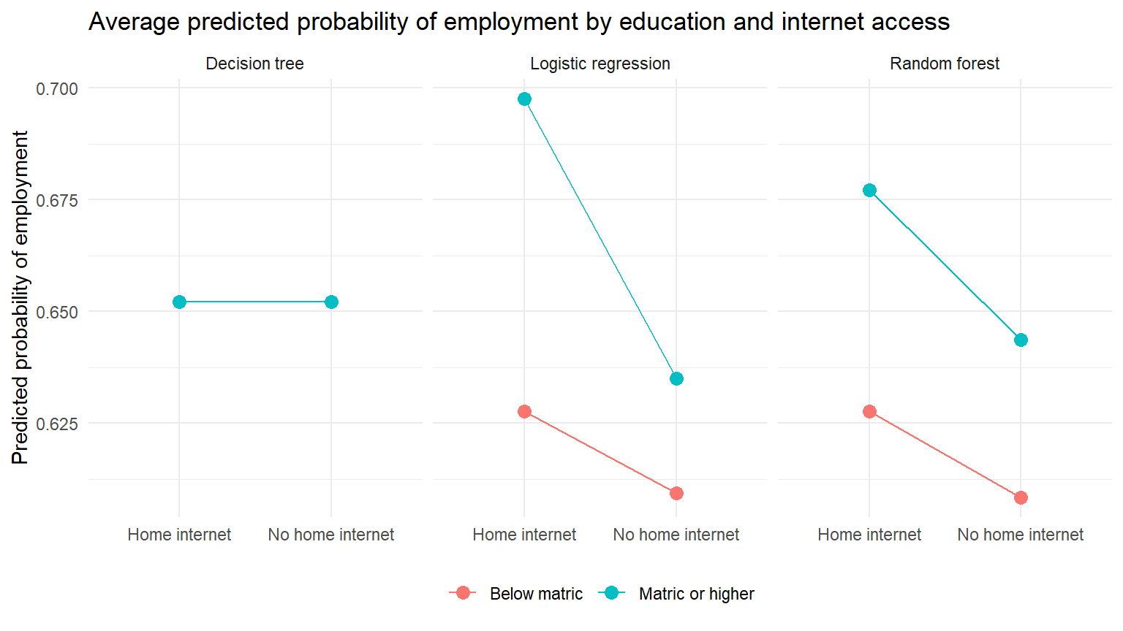
Figure 4: Predicted probability of employment by education and internet access (non-parallel lines show the interaction)
The logistic regression and the random forest agree on the direction: people with matric gain more from home internet than people without matric. The forest was not told about the interaction and found the same complements pattern on its own, although its estimate is smaller, partly because it averages many trees that often do not split on these two predictors. The decision tree gives the same probability to all four groups because it never splits on education or internet access.

14.3 Do the tree-based models use education and internet access?
The tuned tree does not split on either variable, and the forest ranks matric_plus 11th and any_home_internet last (15th of 15) by permutation importance; age, household size and the device predictors drive its predictions. There are two reasons, both about the data rather than the models: about 85% of the labour force lives in a household with internet access, so splitting on it separates only a small group; and almost everyone with home internet also has a smartphone in the household, so once a tree has split on smartphone_access, any_home_internet adds little. Low importance does not mean internet access is unrelated to employment, only that other predictors carry the same information for prediction.

14.4 Sensitivity check without the device predictors
has_computer and smartphone_access are strongly linked to home internet and may absorb part of its effect (and employment can pay for devices). The logistic regression was therefore refitted without them:
Term | Odds ratio with devices (95% CI) | Odds ratio without devices (95% CI)
matric_plus | 1.148 (0.952–1.383) | 1.337 (1.111–1.608)
any_home_internet | 1.103 (0.942–1.291) | 1.433 (1.262–1.628)
matric_plus × any_home_internet | 1.292 (1.057–1.580) | 1.278 (1.046–1.562)
Interaction LRT p-value | 0.013 | 0.018
Table 17: Sensitivity of the employment odds ratios to the device predictors
The interaction hardly changes and is significant in both versions, so the complements finding does not depend on whether the devices are controlled for. The main effects do change: without the devices, matric and home internet are each clearly associated with higher odds of employment on their own; with them, the internet main effect is small and not significant because smartphone_access carries most of the same information. Which version is reported as “the” internet effect is still to be agreed by the group for the final report; the interaction conclusion is the same either way.

15. Model comparison

15.1 Employment comparison matrix
Criterion | Baseline | Logistic regression (selected) | Decision tree | Random forest
Cross-validated AUC | 0.723 | 0.764 | 0.711 | 0.771
Test AUC (95% CI) | 0.727 (0.713–0.741) | 0.765 (0.752–0.778) | 0.710 (0.696–0.724) | 0.774 (0.761–0.786)
Test AUC gain over baseline | 0.000 | +0.038 | −0.017 | +0.047
Meets AUC ≥ 0.70 | Yes | Yes | Yes | Yes
Balanced accuracy | 0.664 | 0.693 | 0.656 | 0.699
Specificity | 0.687 | 0.679 | 0.549 | 0.728
Brier score | 0.194 | 0.183 | 0.198 | 0.180
Interpretability | High (odds ratios) | High (odds ratios) | High (if-then rules) | Low (black box)
Tests the interaction | No (no education or internet predictors) | Yes (odds ratio and LRT) | No (does not split on either) | Indirectly (group averages)
Uses survey weights | Yes | Yes | No | No
Table 18: Employment comparison matrix

15.2 Income comparison matrix
Criterion | Training average | Baseline | Linear regression (selected) | Random forest
Cross-validated RMSE | 1.149 | 1.037 | 0.948 | 0.943
Test RMSE | 1.145 | 1.038 | 0.949 | 0.937
Test MAE | 0.900 | 0.795 | 0.729 | 0.716
Test R² | −0.021 | 0.161 | 0.298 | 0.316
Interpretability | Trivial | High (% differences) | High (% differences) | Low (black box)
Tests the interaction | No | No | Yes (coefficient and LRT) | Indirectly
Table 19: Income comparison matrix

16. Final model selection
The brief’s key principle is that the highest-scoring model is not automatically the best one. The selection therefore weighs the evidence in sections 13–15 against what each model has to deliver: an answer to Treasury’s complements-or-substitutes question (Milestone 1 success criteria 1, 2 and 4), acceptable performance on the held-out test set (criterion 3), and probabilities that can be shown in a deployed app.
Question | Selected model | Saved as | Key results
Employment (areas B and C) | Survey-weighted logistic regression | Models/employment_logistic.rds, threshold 0.639 | Test AUC 0.765 (baseline 0.727); interaction odds ratio 1.29, LRT p = 0.013: complements
Income (area D, exploratory) | Survey-weighted linear regression | Models/income_linear.rds | Test RMSE 0.949, R² 0.30; interaction +3.1%, LRT p = 0.60: not significant
Table 20: Selected models

16.1 Employment: survey-weighted logistic regression
- It meets the performance criterion. Its test AUC is 0.765, above the 0.70 threshold and clearly above the demographics-only baseline (0.727, DeLong p < 0.0001). Education, digital access and the household predictors therefore add real predictive information beyond who and where a person is.
- It gives up little against the best-scoring model. The random forest has the highest test AUC (0.774). The difference of 0.009 is statistically detectable (DeLong p = 0.0019, somewhat too small because household members are not independent) but small in practice: balanced accuracy 0.693 against 0.699 and Brier score 0.183 against 0.180. Both are well calibrated.
- It is the only model that answers the business question directly. It estimates the education × internet interaction as an odds ratio (1.29) with a likelihood-ratio test (p = 0.013), as the success criteria require, and the survey weights make that estimate describe the South African labour force. The forest can show the interaction only indirectly, through group averages.
- Its result is robust. The random forest, which was not told about the interaction, finds the same complements pattern, and the interaction barely changes when the device predictors are removed. This is the check across a second modelling approach that success criterion 4 requires.
- It is easier to deploy and explain. Every prediction can be traced to odds ratios a policy stakeholder can read, and a regression is small and fast to score in a Shiny app.
The random forest is kept as the predictive benchmark: it shows that a flexible model gains only about 0.01 AUC over the logistic regression, and its predictions correlate with the regression’s at 0.93. The decision tree is not selected: its test AUC (0.710) is below the demographics-only baseline and it never splits on education or internet access, so it cannot serve as the readable check of the interaction it was chosen for. That role is filled by the random forest instead.

16.2 Income: survey-weighted linear regression
The random forest predicts slightly better (test RMSE 0.937 against 0.949, R² 0.316 against 0.298), a difference of about 1% in RMSE. That is too small to outweigh the linear regression’s advantages: it reports salary differences as percentages with confidence intervals, it uses the survey weights, and its residuals behave acceptably. Its answer to the research question is that the interaction is not significant (LRT p = 0.60): among people who report a salary, there is no evidence that home internet changes the salary premium for matric. Both models explain only about 30% of the variation in log salary, so the income results remain exploratory, as planned in Milestone 1.

17. Limitations carried into Tasks 3 and 4
A model can perform well overall but worse for particular groups. The test-set metrics of the selected logistic regression, by population group, sex and settlement type:
Group | Test people | Share employed | AUC | Sensitivity | Specificity
Black African | 4,642 | 0.609 | 0.749 | 0.652 | 0.711
Coloured | 512 | 0.758 | 0.717 | 0.838 | 0.411
Indian/Asian | 104 | 0.856 | 0.831 | 1.000 | 0.200
White | 316 | 0.921 | 0.697 | 0.986 | 0.040
Male | 2,867 | 0.679 | 0.770 | 0.773 | 0.605
Female | 2,707 | 0.610 | 0.757 | 0.630 | 0.745
Metro urban | 2,244 | 0.699 | 0.758 | 0.770 | 0.578
Non-metro urban | 1,582 | 0.665 | 0.764 | 0.794 | 0.583
Traditional | 1,527 | 0.534 | 0.732 | 0.452 | 0.850
Farms | 221 | 0.724 | 0.809 | 0.825 | 0.656
Table 21: Logistic regression test-set performance by group
- One threshold meets very different base rates. The AUC is similar across groups, so the model ranks people about equally well within each group, but for the Indian/Asian and White groups (over 85% employed) the model almost never predicts Unemployed (specificity 0.2 or lower), and in traditional areas it misses more than half of the employed people (sensitivity 0.45). The random forest shows the same pattern. The selected model is therefore suited to estimating group-level patterns and “what-if” scenarios, not to making decisions about individuals. This feeds into the fairness evaluation (Task 3).
- Associations, not causes. All results come from one 2024 cross-section. The odds ratios describe how employment differs between groups, not what would happen if a person gained matric or internet access.
- Uncertainty is slightly understated in two places. The DeLong tests and the ROC confidence intervals treat people as independent, although household members are not.
- The income results are exploratory. They cover only employed people who reported a salary, and the models explain about 30% of the variation.

18. Reproducibility of the tuning and evaluation
- Every random step uses seed 67: the cross-validation folds (set.seed(67) before caret::groupKFold()) and every forest (seed = 67 in ranger()). Rerunning the notebook gives the same folds, tuned settings and test results. With the seed set, ranger gives identical forests whatever number of processor threads it uses. The tree and the regressions have no random steps.
- The test files are read only after all tuning and threshold choices are fixed, and are used once.
- Every metric (cross-validation, test set and subgroups) is calculated by the same helper functions, written once at the top of the notebook.
- The notebook saves employment_tree_tuned.rds, employment_forest_tuned.rds, employment_baseline.rds, income_forest_tuned.rds, income_baseline.rds and employment_thresholds.csv to Models/. The selected models, employment_logistic.rds and income_linear.rds, were saved by the modelling notebooks and are not changed.
- Packages: R 4.6.1 with survey 4.5, rpart 4.1.27, rpart.plot 3.1.5, ranger 0.18.0, pROC 1.19.1 and caret 7.0-1 (for groupKFold() only). The full sessionInfo() is at the end of the rendered notebook, Rendered Documentation/Milestone 3/Model Evaluation.html.

